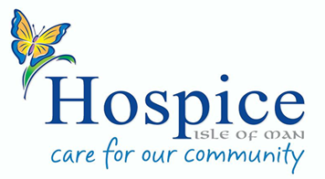
JOB DESCRIPTION & PERSON SPECIFICATION
Clinical Staff |  | Non-Clinical Staff |  | Volunteers |  | Flexi-Bank Staff

ROLE: | Volunteer Administrator
REPORTS TO: | Head of People and Culture
LOCATION: | Hospice Isle of Man

PURPOSE OF ROLE:
Working with our administration teams you will provide administration and/or secretarial support to Hospice Isle of Man. This may include areas such as HR, Education, Finance, Income Generation, Volunteer office, clinical administration or to the CEO office. This role can be varied depending upon your skills and experience and the tasks required.
KEY ACTIVITIES:
- Working closely and communicating effectively with teams In Hospice
- Undertaking specific administrative tasks, with support/supervision
- Ensuring our administrative work is carried out to a high standard of accuracy
- Undertaking routine administration tasks such as photocopying, compiling letters and other documents, filing and making telephone calls
- Working with confidential information and sensitive issues
- Providing support to committees with minutes of meetings
- Any general administrative tasks as required, on agreement with you

Health and Safety
For all Team Members
Hospice Isle of Man is dedicated to the health safety and welfare of all its staff and volunteers. All staff and volunteers will be responsible for their own health, safety and welfare, and that of others who may be affected by their actions or omissions, and for identifying and reporting any possible risks or near misses to a responsible manager. All staff and volunteers will be required to observe appropriate legislation and codes of practice in connection with their role and will be provided with training and support to do so.

Person Specification: What we need you to bring
Qualifications: | Is it essential or desirable | How we will assess
GCSE or equivalent in English | D | A & I
Experience:
Administration experience | E | A & I
Experience of dealing with confidential information | D | A & I
Experience of working in a team | D | A & I
Skills/Competencies:
Good organisational skills | E | A & I
Competent in Microsoft Office, e.g. Word and Excel | E | A & I
Excellent communication skills | E | A & I
Personal Qualities/Behaviours:
Friendly and approachable | E | I
Discretion and confidentiality | E | I
Other:
DBS check is required for this role | E | A & D

